**10**

**2. Identify and document system exceptions**

Exception is an unwanted or unexpected event, which occurs during the execution of a program, i.e. at run time, that disrupts the normal flow of the program’s instructions. Exceptions can be caught and handled by the program. When an exception occurs within a method, it creates an object. This object is called the exception object. It contains information about the exception, such as the name and description of the exception and the state of the program when the exception occurred.

**Types of Exceptions**

Java defines several types of exceptions that relate to its various class libraries. Java also allows users to define their own exceptions

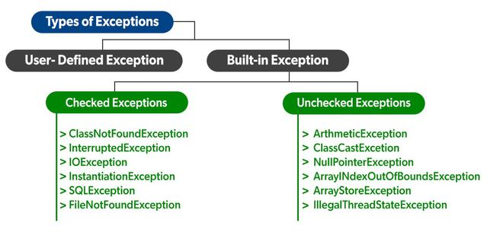

**Example of Exception**

|  |
| --- |
| Public class javaExceptionExample {  Public static void main(String args[]) {  Try {  Int data = 100/0;  }catch(ArithmeticException e) {System.out.println(e); }  System.out.println(“rest of the code…”);  }} |